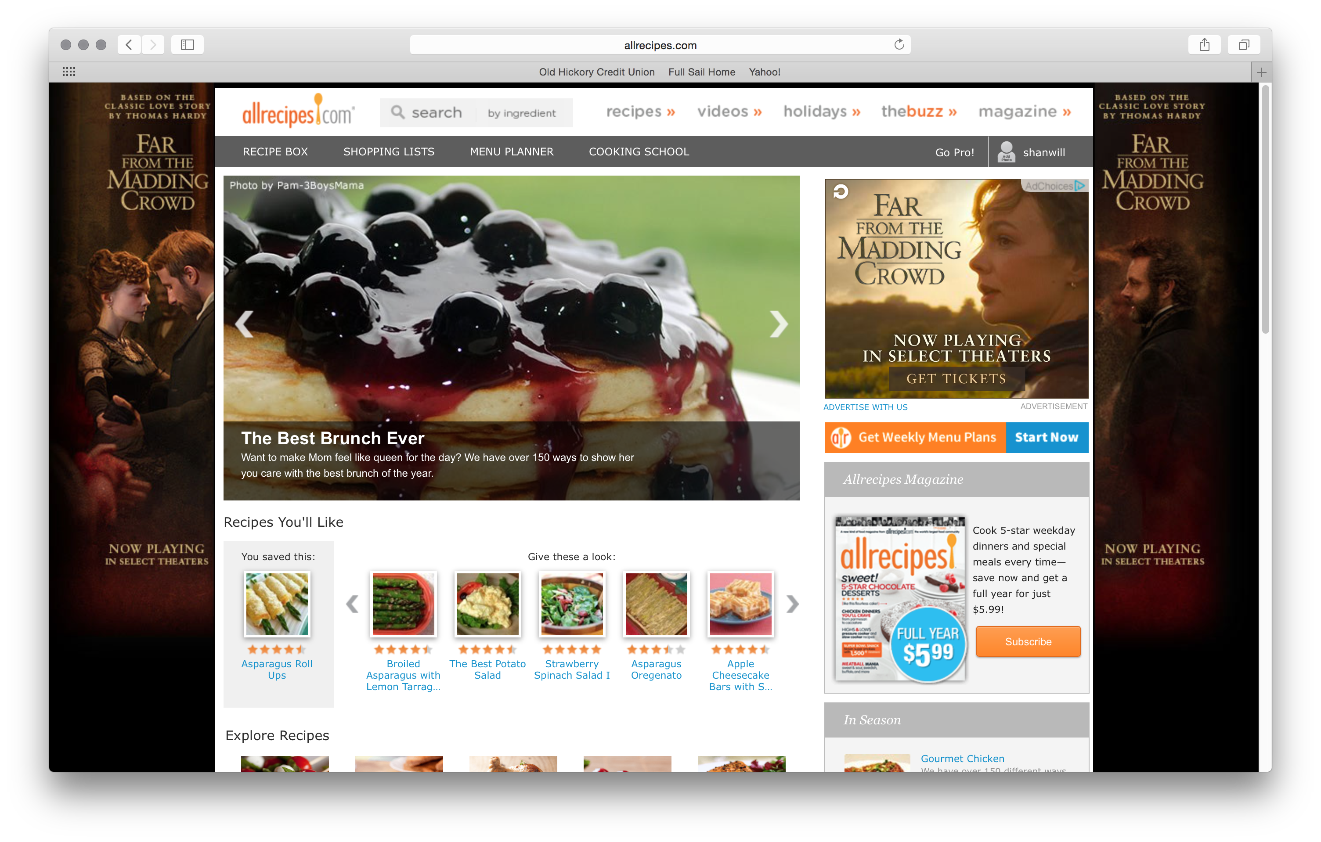

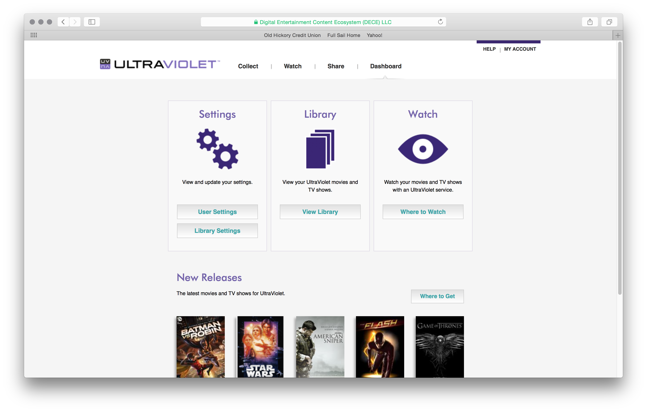

These two websites, I use on a fairly regular basis. I love movies and I love to cook. That is the target audience! The top site is too cluttered to me. Advertisements cover both sides of the page as well as a video commercial for the advertisement that plays automatically with no way to stop it. That is 30 seconds of noise that I don’t care to hear. The rest of the site is laid out very well. I like the fact that the recipe search is at the very top and can be search by food or ingredient or meal. A specific search is great for people that know what they want and don’t want to wade through a bunch of nonsense.

The second site is for the digital movie library through UltraViolet. It is very clean and straight to the point; login, here’s your library, now watch. Done! The only other thing on the page is a recommendation for newly released titles that may interest me.